Date : 02-04-2024

Backup and Restore

Q1 >>> I'm planning to update or upgrade my EC2 OS >>> Complete ec2 level maintenance >>> Backup >>>>??? "AMI"

Q2 >>> I'm planning to do some change in my EBS Vol >>>> Only at the particular Vol level maintenance >>>> Backup >>>> ??? Snapshot

Q3 >>> Launch 20 Same EC2 instances with >> Same OS/ Applications/Configurations >>>>> ??? AMI

Q4 >>> I want to Migrate or Move or Copy from EC2 instance from one Region to Another Region >>>>> ??? AMI

Q5 >>>> I have launched my EC2 with my Key-Pair and it doesn't have any custom Usernames and unfortunately I lost my key-pair, How can I troubleshoot or login my EC2 >>> ???

ANS od Q5 >>>Create AMI >> Launch a new EC2 with new Key-Pair and you can login with your new server with new key-pair

AMI &&& Snapshot

Three Benefits of AMI >>>>

1 - Preserved Copy your OS >>>> Quick start, Community or Marketplace AMI

2 - Backup >>> AMI

3 - Golden Image

EC2 >>> 2-3 Mints

Post Build

App >> 1hr

Config >> 1 hr

Policies

Permissions

Rules

etc

3-4 hours

20 EC2 >>>>> 20 EC2 * 3 Hours >>>>

Launch your 1st EC2 >>>> Do all your post Build >>> Create a AMI out of it >>> Launch the remaining 19 EC2 from My AMI >>> Golden Image >> Template

whenever AMI >>>> MyAMI

Ec2 with one Vol

Snapshot

Laptop >>>> C:/ >>> 100 GB

D:/ >>> 200 GB

E:/ >>> 200 GB

C:\ G Drive or External HDD <<<<< 100Gib >>>> EBS Snapshot

Laptop >>>> 500 GB >>>>> AMI (EC2 AMI along with all residing EBS Vol Snapshot)

1 AMI along with 3 EBS Snapshots

whenever you create AMI >>> All the EBS Vol snapshots will be creating automatically

But, whenever you delete your AMI >> you have to delete EBS snapshots separately and Manually.

Create a Vol and attach the Linux EC2

How to create a EBS Snapshot

Then, Choose your New volume >>> Actions >>> Create a Snapshot

Give your Description >>> Create a Snapshot

LAB Start now

Now Go to EC2 Instance and create a Ubuntu EC2 instance .

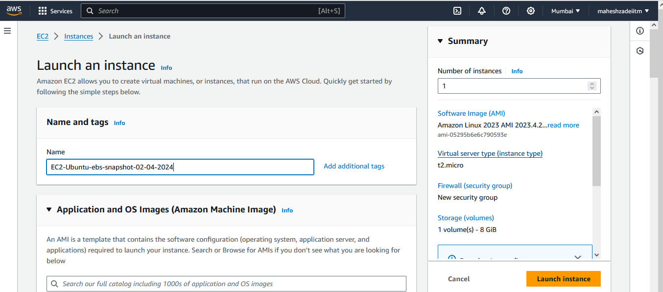

Edit network setting and select the Custom VPC , Public Subnet and Assign public IP.

Security group

Click on launch Instance

Copy public IP and check the its connecting by public IP

I am able to connect with public IP

Check the EBS Volume A and Availability Zone of EC2 Instance (ap-south-1a)

Now Go to Volume

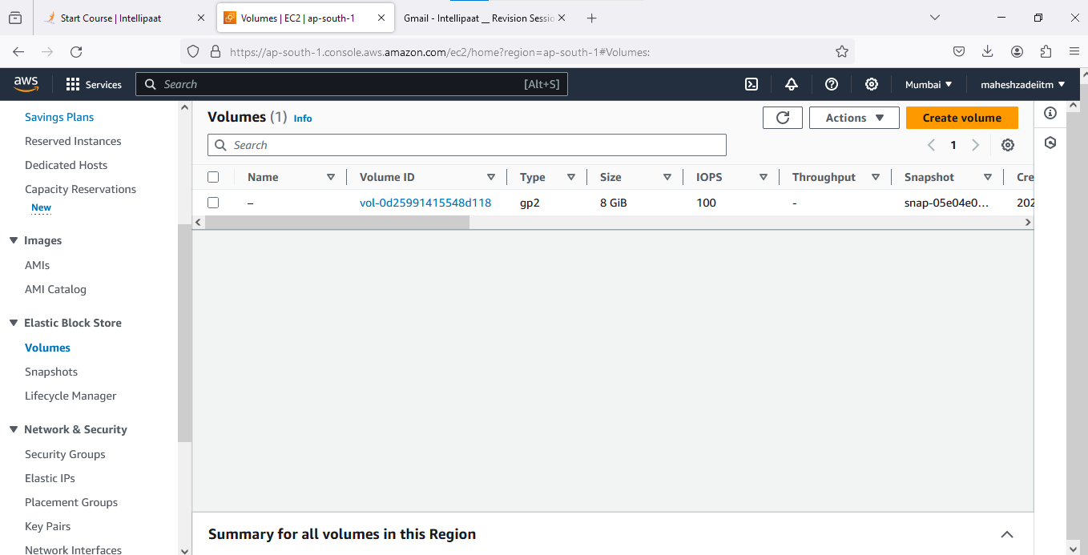

Click on Create Volume

Change size of EBS to 1 Gib from 100 Gib as it will cost us

Select Availability Zone ap-south-1aas our EC2 having the same AZ.

Click on encrypt this Volume

And KMS key ( key management system ) ( default)

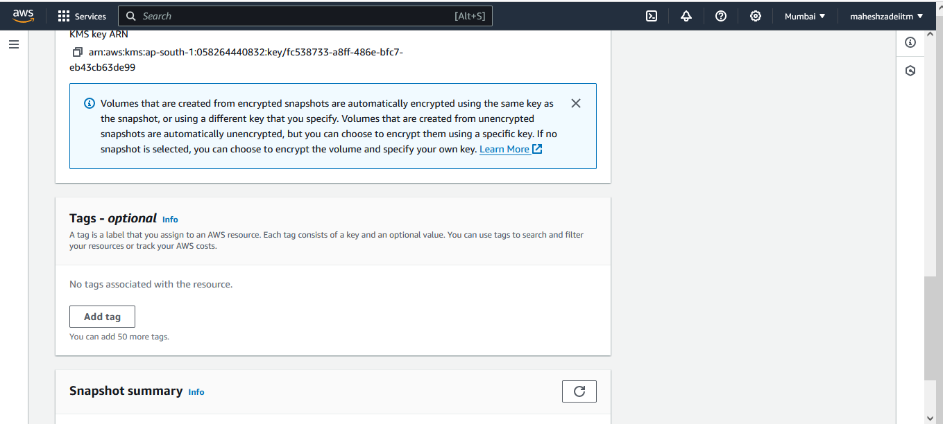

Click on create Volume

Volumes are created

Check it is available or not

Name the EBS Volume which we created as ubuntu-ebs

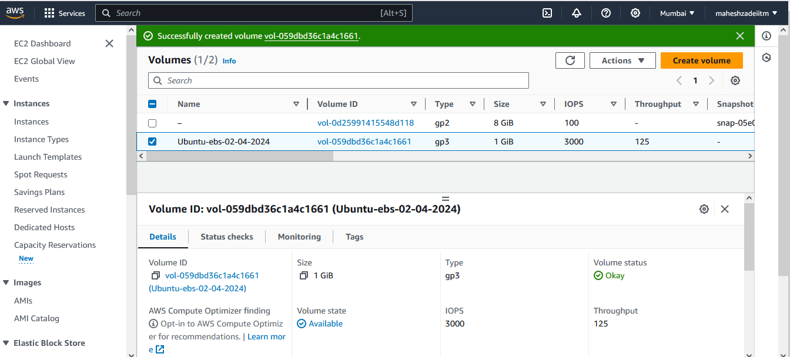

Also check KMS ID Genetared

KMS ID : fc538733-a8ff-486e-bfc7-eb43cb63de99

Now attach 1 Gib to EC2 instance

**Go to action and attach volume**

**Select Instance id and selec the device name**

**Successfully attach the Volume**

**Now check in EC2 Ubuntu instance EBS Volume is attached .**

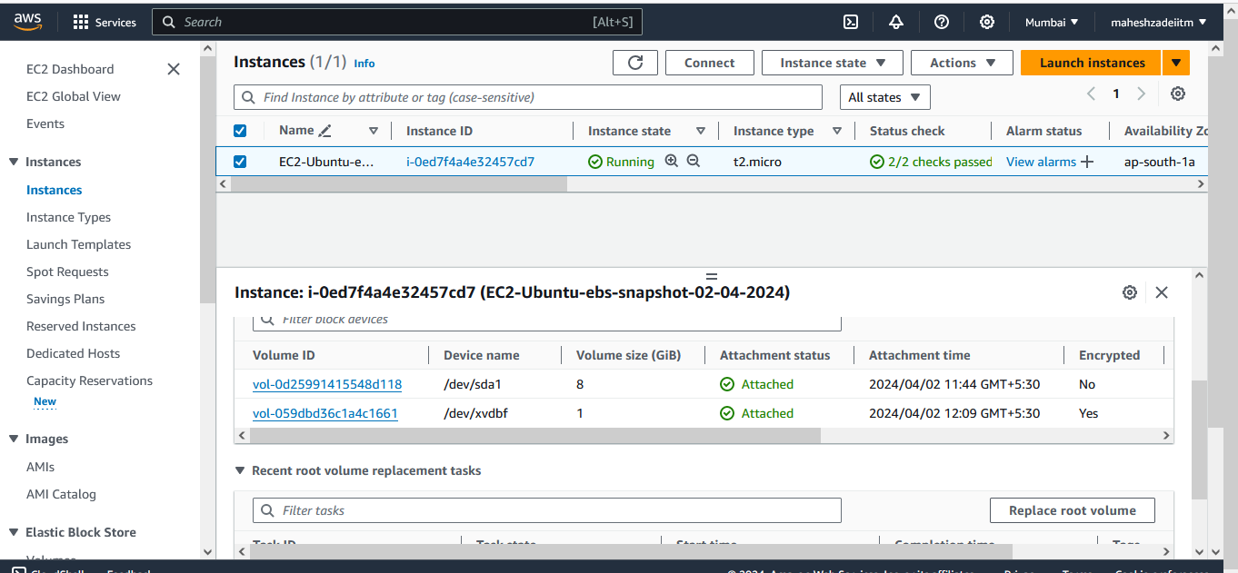

**Now Modify the Volume**

**Go to Volume -Selct the 1 Gib Volume and go to action and click on modify the volume**

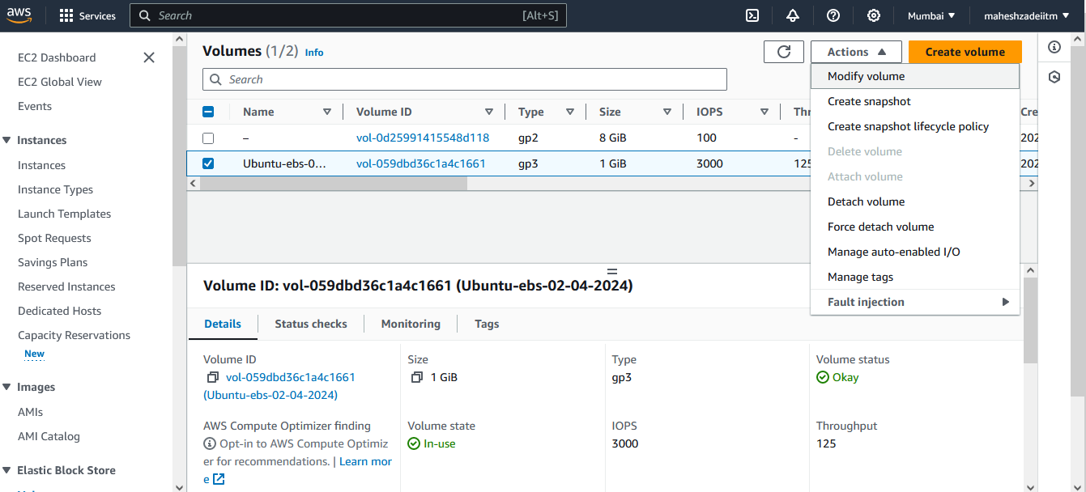

**U can increase the volume bu u can not decrease the volume.**

**Change the Volume size to 1 to 2 Gib**

**Click on modify volume**

**Again click on modify**

**Now see the EBS Volume increased to 2 Gib**

**Now check in EC2 Instance it is upgraded or not and refresh the EC2 Page.**

**Now create the EBS Volume snapshot**

**Go to Volume >> Go to Action and click on create the snapshot**

**Give the snapshot description**

**Click on create the snapshot**

**Snapshot created successfully**

**Now go to snapshot and check it is created or now and give the Name to snapshot**

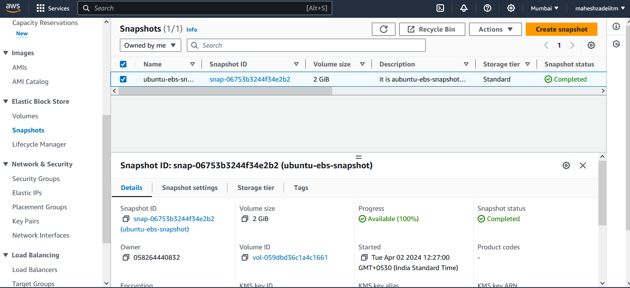

**Snapshot is nothing a backup of your EBS Volume.**

**If by mistake the EBS Volume got deleted then how we can**

**Detach volume Assume its deleted and then how we can recover the EBS Volume from the snapshot**

**Detach volume**

**Delete volume for example and the we can how we recover the EBS Volume from snapshot**

**Now Go to Snapshot >> Go to Action > Select the Snapshot and click on create the volume from the snapshot**

**And select the Availability Zone of EC2 Instance correctly .**

**AZ-**ap-south-1a

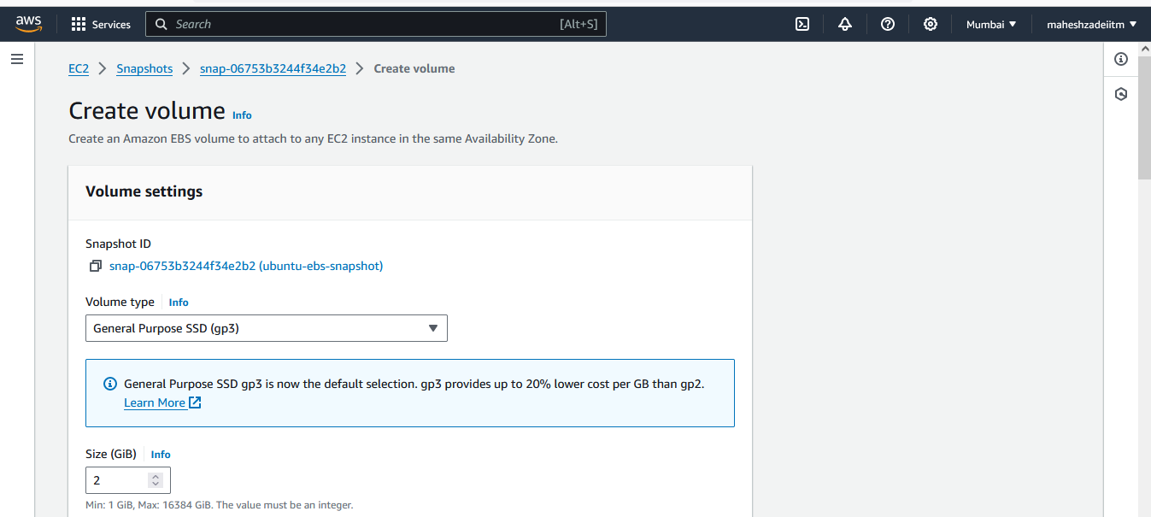

**Click on create volume**

**EBS Volume created**

**Again we have to attach to EC2 Instance once the EBS Volume is created by snapshot .**

**Click on attach volume**

**Again Check in EC2 Instacne Storage tab EBS Volume is attached**

**Pls ref the below screen shot**

**Thanks**

**Pls delete EC2 , EBS and Snapshot after the Lab**

**Thanks once again**